Math Tracking Chart

- Find the grade and class you are in currently.
- Choose the next class you will take. Use the flow chart to determine the appropriate class.
- If you would like to choose a class that is not shaded the same as your current class, you must also fill out a Teacher Approval Form and have it properly signed.
- Those going into 9th grade should follow the recommendation given to them or fill out a Teacher Approval Form and have it properly signed.
- Students get elective credit for Algebra 1 or Advanced Algebra 1 taking in 8th grade. All students must complete 3 years of math while in high school.
- Probability and Statistics is an alternative math course that can be taken after Algebra 2.

8th grade 9th grade 10th Grade 11th Grade 12th Grade

Pre
-
Algebra

Algebra 1

Geometry

Algebra 2

Algebra 3

(ICC Dual Credit option for S1)

or

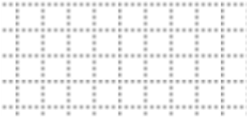

Algebra 1

Algebra 2

Algebra 3

(ICC Dual Credit option)

Honors
Pre-Calculus

Geometry

Accelerated
Geometry

Accelerated
Algebra 2

Honors

Pre-Calculus

AP Calculus

Advanced

Algebra

1

